**Where Does the Term “Bean Counter” Come From?**

The term “Bean Counter” usually isn’t used in the nicest of ways. It’s usually used to describe someone who takes a love of tracking numbers and pennies too far. The term was first used in England in the early 1900s.

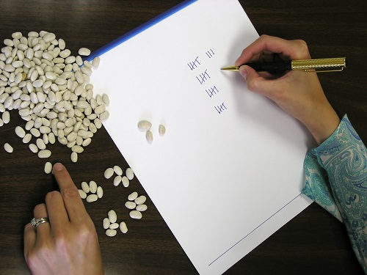

Some people think the phrase refers to people who were so picky about getting what they paid for they’d count each bean they bought from the store. Because one bean might not be enough to tip the scale, they would count out each bean to get the most beans they could without changing how much they’d be charged.

Basically, they were so stingy with money that they would waste their time, and everyone else’s, making sure they got the most while paying the least—down to the penny!—even though in the long run, a few pennies doesn’t make a big difference.

So now the term refers to people who get so hung up on the details of numbers that they end up wasting more time and money than it’s worth to find out those details.

***What You Can Learn from Chores***

**Life skills** — Doing the laundry might not seem important, but there are a lot of college kids who just can’t figure it out.

**Responsibility** — Learning how to finish tasks is super important when you have a job and you’re responsible for managing your own money, balancing a college schedule, etc.

**Planning** — Knowing how to plan your time so you can finish your chores and still play is huge!

**Teamwork** — Believe it or not, cleaning your room is actually helping the team, your family, keep the house clean.

**Finding fun in boring things** — Not everything in life is a ton of fun. But everything can be made fun. How fast can you pick up your toys? Can you vacuum the rugs before your sibling finishes the dishes?

Chores aren’t a punishment, it’s actually a reward in disguise!

